DEPARTMENT OF ELECTRICAL AND ELECTRONICS ENGINEERING 19EE103T – BASIC ELECTRICAL ELECTRONICS AND COMMINICATION ENGINEERING

PART – B (2 MARKS)
UNIT – I DC CIRCUITS

- Define electric current?
Electric current is defined as the rate of flow of electric charge I= dq/dt amperes, where ‘q’ is the charge in coulombs. The unit of current is the ampere which is the current that flows when 1 coulomb of charge is transferred in one second.

Define electrical potential?
This is generally measured between two points and its unit is in volt. If the work done in moving a charge of one coulomb between the two points is 1 joule, then we say that the potential of one point with reference to the second point is 1 volt. E= dW/dQ

Define conductance?
The reciprocal of resistance is called conductance.
Unit: Siemens (G) G = 1/R

Define resistance.
Resistance is the property of the material by which it opposes the flow of current through it. The resistance of element is denoted by the symbol ‘R’. Resistance is measured in ohms (Ω).

Define inductance.
Inductance is the element in which energy is stored in the form of electromagnetic field.
The inductance of element is denoted by the symbol ‘L’. Inductance is measured in henry (H).

Define capacitance.
Capacitance is the element in which energy is stored in the form of electrostatic field. The capacitance of element is denoted by the symbol ‘C’. Capacitance is measured in farads (F).

State ohm’s law? What are the limitations of ohm’s law.
When the temperature remains constant, current flowing through a circuit is directly proportional to potential difference across the conductor. Eα I or E = IR, where R the constant of proportionality, becomes the resistance when E is volt and I is in amperes.

Limitations:
  - It is not applicable to the nonlinear devices such as diodes, zener diodes, voltage regulators etc.
  - It does not hold good for non-metallic conductors such as silicon carbide.

Write down the expression for effective resistance when two resistances are connected in series and parallel.
For series connection:R = R1 + R2
For parallel connection R = R1R2 / (R1+R2)

State Kirchoff’s laws
Kirchoff’s current law: The sum of the current flowing towards a junction is equal to the sum of the currents flowing away from it. (Draw Diagram)
Kirchoff’s voltage law: In a closed circuit, the sum of the potential drops is equal to the sum of the potential rises. (Draw Diagram)

State voltage division rule.
It states voltage drop across any resistor, or combination of resistors, in a series circuit is equal to the ratio of that resistance value to the total resistance, multiplied by the source voltage.

State current division rule.
It states the current in any branch in a parallel circuit is equal to the ratio of opposite branch resistance value to the total resistance, multiplied by the total current in the circuit.

List out the characteristics of series circuits.
  - The same current flows through each resistance.
  - The supply voltage V is the sum of the individual voltage drops across the resistances.
V = V1+V2+V3+………+Vn
  - The equivalent resistance is equal to the sum of the individual resistances.
  - The equivalent resistance is the largest of all the individual resistances.

Distinguish between power and energy.
Sl.No | Power | Energy
1. | The rate at which work is done is called electric power. | The capacity to do work or the total work done is called energy.
2. | Power (P) = VI Where V—Voltage  I – Current | Energy = VIt Where V—Voltage  I --- Current t --- Time
3. | Unit : Watts | Unit : Watt-Hour

- Write down the expression of equivalent resistance for ‘n’ – number of resistors in series connection.
For ‘n’ resistors connected in series, the equivalent resistance is given by, Req=R1+R2+R3+… +Rn

- Write down the expression of equivalent resistance for ‘n’ - number of resistors in parallel connection.
For ‘n’ resistors connected in parallel, the equivalent resistance is given by,

1 =
Re q
1 + 1 +
R1 R2
1 + ......... + 1
R3 Rn

- Write the Algorithm for Nodal Analysis.
Select a node as the reference node. Assign voltages V1,V2,…Vn-1 to the remaining n-1 nodes. Apply KCL to each of the n-1 nodes. Solve the resulting simultaneous equations to obtain the unknown node voltages.
- Write the Algorithm for Mesh Analysis.
Assign mesh currents i1,i2,….in to the ‘n’ meshes. Apply KVL to each of the ‘n’ meshes. Solve the resulting ‘n’ simultaneous equations to get the mesh currents.

- Distinguish between a Loop & Mesh of a circuit.
The closed path of a network is called a Loop. An elementary form of a loop which cannot be further divided is called a mesh. In other words Mesh is closed path does not contain an other loop within it.

PART – C(16 MARKS)
  - In the circuit shown in fig. calculate (i) the current in other resistors (ii) the value of unknown resistance ‘X’ (iii) the equivalent resistance across AB.
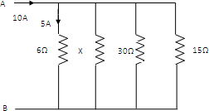
  - Determine the power dissipated by 5 ohm resistor in the circuit shown in figure.
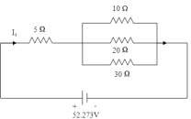
  - Find the nodal voltages VA and VB by nodal analysis.
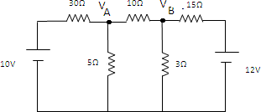
  - Determine the current through 47 Ω resistor for the circuit shown in figure using mesh analysis.
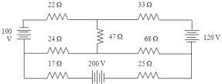

  - Determine the potential difference between node 1 and 2.

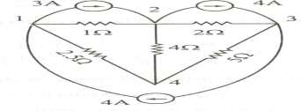
  - Find Rab in the circuit shown in figure.
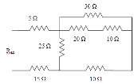
  - Find the equivalent resistance between A and B.
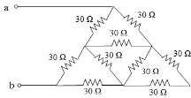
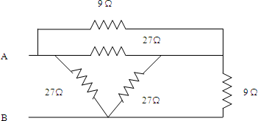
  - Find the equivalent resistance between A and B

